|  |  |
| --- | --- |
|  | **LDCW6123 FUNDAMENTALS OF DIGITAL COMPETENCE FOR PROGRAMMERS**  Trimester 2, 2023/2024 |

**GROUP PROJECT**

**Lecturer : Mr. Muhammad Arif Bin Hasan**

**Group: 03**

*Prepared by:*

|  |  |  |
| --- | --- | --- |
| **Student ID** | **Student Name** | **Phone number** |
| 241UT2410A | BRIAN LEE CHONG MING | 012-248 1351 |
| 241UT2410B | CHU WEI WANG | 011-5641 7215 |
| 241UT2410C | YAP TZE SYN | 016-926 7193 |
| 241UT2410D | LIM JIANG CHING | 017-632 2134 |

**Declaration by group leader**

I hereby declare that all group members’ names are correctly included in the above section. I hold a copy of this assignment which I can produce if the original is lost or damaged. I certify that no part of this assignment has been copied from any other student’s work or from any other source except where due acknowledgement is made in the assignment.

Student signature : BRIAN

Student name : BRIAN LEE CHONG MING

Student ID : 241UT2410A

Date : 31 May 2024

**Group member declaration**

*(Each group member, including the* ***group leader****, must individually fill up and submit this form)*

Group member’s name : BRIAN LEE CHONG MING

For the purpose of completing this assignment, I have performed the following tasks (please list):

* **Homepage (Website)**
* **About Us (Website)**
* **Website design**
* **Mobile App prototype**

*I hereby declare that I have assessed this submission and I take full responsibility should there be any inaccuracies, incompleteness, omissions, delays or non-submission.*

Group member’s signature : **BRIAN**

Group member’s name : BRIAN LEE CHONG MING

Group member’s ID : 241UT2410A

Group member’s tel. no. : 012-248 1351

Group member’s email : BRIAN.LEE.CHONG@student.mmu.edu.my

Date : 31 May 2024

**Group member declaration**

*(Each group member, including the* ***group leader****, must individually fill up and submit this form)*

Group member’s name : CHU WEI WANG

For the purpose of completing this assignment, I have performed the following tasks (please list):

* **Merchandise (Website)**
* **About Us (Website)**
* **Website design**
* **Mobile App user manual**

*I hereby declare that I have assessed this submission and I take full responsibility should there be any inaccuracies, incompleteness, omissions, delays or non-submission.*

Group member’s signature : ***Kyro***

Group member’s name : CHU WEI WANG

Group member’s ID : 241UT2410B

Group member’s tel. no. : 011-5641 7215

Group member’s email : CHU.WEI.WANG@student.mmu.edu.my

Date : 31 May 2024

**Group member declaration**

*(Each group member, including the* ***group leader****, must individually fill up and submit this form)*

Group member’s name : YAP TZE SYN

For the purpose of completing this assignment, I have performed the following tasks (please list):

* **Homepage (Website)**
* **Sidebar (Website)**
* **Website design**
* **Mobile App user manual**

*I hereby declare that I have assessed this submission and I take full responsibility should there be any inaccuracies, incompleteness, omissions, delays or non-submission.*

Group member’s signature : **Syn**

Group member’s name : YAP TZE SYN

Group member’s ID : 241UT2410C

Group member’s tel. no. : 016-926 7193

Group member’s email : YAP.TZE.SYN@student.mmu.edu.my

Date : 31 May 2024

**Group member declaration**

*(Each group member, including the* ***group leader****, must individually fill up and submit this form)*

Group member’s name : LIM JIANG CHING

For the purpose of completing this assignment, I have performed the following tasks (please list):

* **Plans & Subscription (Website)**
* **Albums (Website)**
* **Website design**
* **Mobile App prototype**

*I hereby declare that I have assessed this submission and I take full responsibility should there be any inaccuracies, incompleteness, omissions, delays or non-submission.*

Group member’s signature : **Ching**

Group member’s name : LIM JIANG CHING

Group member’s ID : 241UT2410D

Group member’s tel. no. : 017-632 2134

Group member’s email : LIM.JIANG.CHING@student.mmu.edu.my

Date : 31 May 2024

**CONTENT PAGE NO.**

* 1. WEBSITE URL LINK 7
  2. MOBILE APPS URL LINK 7
  3. MOBILE APPS USER MANUAL 7

**Links & Mobile App User Manual**

<https://wix.to/ejA5giF> - Website URL Link & Mobile App URL Link ( Swap in between Desktop & Mobile View )

[Page 1 - FDC Wireframe (figma.com)](https://www.figma.com/proto/RWlAy1fI44wtCPTw2J97iB/FDC-Wireframe?node-id=1-105&t=c6k4bp4FFpdXAZPL-0&scaling=scale-down&content-scaling=fixed&page-id=0%3A1&starting-point-node-id=1%3A105) – Mobile App Prototype Link

<https://www.canva.com/design/DAGIfHFy-70/Z4KyObttpVGY4im3G4_P6Q/edit?utm_content=DAGIfHFy-70&utm_campaign=designshare&utm_medium=link2&utm_source=sharebutton> – User Manual

Homepage

Student

Artist’s Album

Clothes

Family

Duo

Individual

Contacts

Provided services

Objectives

Albums

Merchandise

About Us

Plans & Subscription

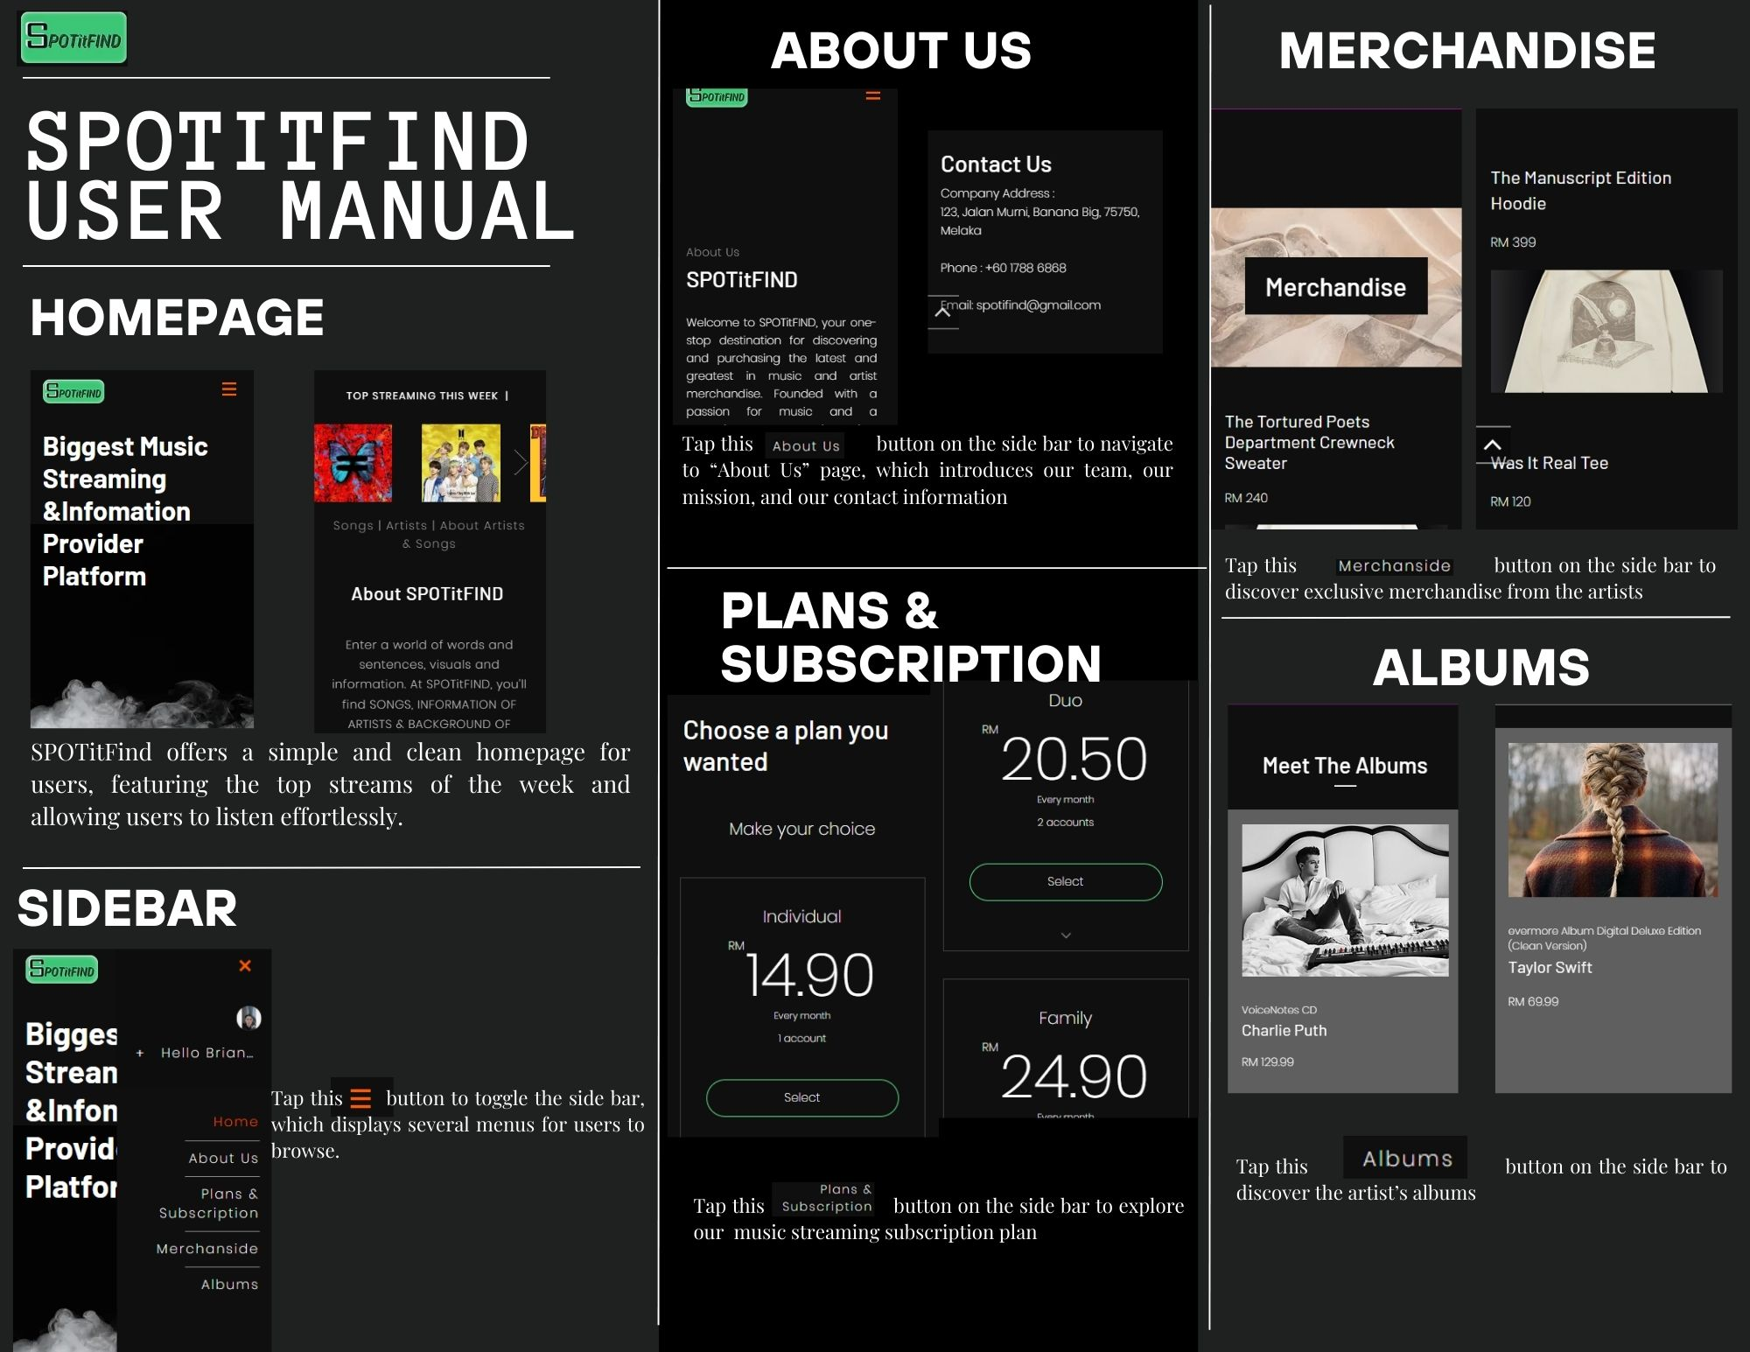

Figure 1: Mobile App User Manual